NRIS+ and Expedited Designation FAQ

Q: What is NRIS+?
A: NRIS+ is a shorthand term that refers to the additional features that were added to the NRIS (Network Resource Interconnection Service) product in FERC Docket# ER25-464 (SPP Revision Request RR649). The SPP tariff has no product called “NRIS+”. SPP still offers only two interconnection products: ERIS (Energy Resource Interconnection Service) and NRIS.

Q: What new features were added to the NRIS product with the NRIS+ filing?
A: First, in the interconnection study process, NRIS requests are now studied to determine the upgrades needed to deliver to any loads located in the same Deliverability Area. Second, a streamlined process was created to allow transmission customers to designate NRIS generators as network resources without going through the Aggregate Transmission Service Study. The streamlined process is called the Expedited Designation process.

Q: Are all interconnection requests that selected NRIS effectively studied with the updated NRIS definition (NRIS+) and criteria?
A: Yes, all requests starting with the Expedited Resource Adequacy Study (ERAS) and the 2024 Definitive Interconnection System Impact Study (DISIS) are studied for deliverability and are eligible to use the Expedited Designation process.

Q: Does an interconnection customer need to request NRIS+ specifically to receive the additional features?
A: No, all new NRIS generators starting with ERAS and DISIS-2024 will have the new features automatically. In addition, all NRIS requests prior to those studies as well as existing generators with NRIS and some with ERIS were given the additional features with some limitations. See Tariff Section 30.1.2.

Q: What about NRIS generators prior to ERAS and 2024 DISIS?
A: Existing Designated Resources and NRIS generators with executed GIAs on October 19, 2022, were studied to determine how much output could be delivered to their Deliverability Area. Pending requests in DISIS clusters 2017 through 2023 were granted deliverability limited to the study group/control area only within their Deliverability Area. The amount of deliverable output—the Network Resource Deliverability (NRD) and the Deliverability Area for each of these generators is documented in the NRD spreadsheet.

Q: How can an NRIS generator achieve deliverability to the entire Deliverability Area or increase the amount of Network Resource Deliverability?
A: To remove a limitation or increase deliverability, the customer should submit a new request into the interconnection cluster study process requesting full deliverability.

Q: What is the purpose of the Expedited Designation process?
A: The Expedited Designation process provides an alternative to the Aggregate Transmission Service Study (ATSS) process for requests to receive long-term transmission service if certain requirements are met. As the GI study process now evaluates deliverability and any associated upgrades for NRIS requests, resources that have NRIS are not subject to additional upgrades for transmission service if certain requirements are met. The Expedited Designation process allows Network Customers to quickly add new resources to their fleet of network resources without additional upgrade requirements.

Q: What makes a resource eligible for the Expedited Designation process?
A: Any request in which the source has NRIS service and/or has been assigned Network Resource Deliverability and will be serving Network load in the same Deliverability Area is eligible for the Expedited Designation process.

Q: What is required to initiate an Expedited Designation study?
A: There must be Network Resource Deliverability for the resource, which requires obtaining NRIS service. The customer must submit an Expedited Designation Study Agreement, a NITS Application, and a valid OASIS request (ADDNITSDNR) to TS@spp.org. The resource must be in the same Deliverability Area as some or all of the customer’s load. The MW in the OASIS request cannot exceed the Network Resource Deliverability of the resource. If some of the customer’s load is in a different Deliverability Area than the resource, the MW in the OASIS request cannot exceed a pro-rated amount of the Network Resource Deliverability as described in Tariff Section 30.2.2.
The Expedited Designation Study Agreement and NITS Application can be found on the Transmission Service studies posting page.

Q: How long does the Expedited Designation study process take?
A: The process takes approximately 90 Calendar Days; this includes 60 Calendar Days for the study and 30 Calendar Days for updating the NITS Agreement. Per Tariff Section 30.2.2, the Application must be submitted at least 90 days prior to the start date of the OASIS request.

Q: Is a deposit required for an Expedited Designation request?
A: No deposit is required for an Expedited Designation study. The customer will be billed for study costs at the conclusion of the study.

Q: What are the Deliverability Area definitions?
A: Deliverability Areas consist of the Transmission Owners’ facilities located in the following Tariff Attachment H Zones as documented in Business Practice 7250 and reproduced below. These Deliverability Area definitions apply to all NRIS requests queued in the 2024 DISIS, ERAS and later studies. The Deliverability Area may be different for requests that were queued in the 2017 through 2023 DISIS clusters. The exact Deliverability Area definition for every eligible generator is documented in the Network Resource Deliverability (NRD) spreadsheet.

Deliverability Areas:

South Deliverability Area
#1 American Electric Power – West
#5 Grand River Dam Authority
#7 Oklahoma Gas and Electric
#10 Southwestern Power Administration
#11 Southwestern Public Service Company
#13 Western Farmers Electric Cooperative

Central Deliverability Area
#2 Kansas City Board of Public Utilities
#3 City Utilities of Springfield, Missouri
#4 Empire District Electric Company
#6 Evergy Metro
#8 Midwest Energy
#9 Evergy Missouri West
#12 Sunflower Electric Power Corporation
#14 Evergy Kansas Central

North Deliverability Area
#16 Lincoln Electric System
#17 Nebraska Public Power District
#18 Omaha Public Power District
#19 Upper Missouri Zone (Eastern Interconnection)

Montana Deliverability Area
#19 Upper Missouri Zone (Western Interconnection)

Rocky Mountain Deliverability Area
#100 - Colorado Springs Utilities
#101 - Platte River Power Authority
#102 - Tri-State Generation and Transmission Association
#103 – Colorado River Storage Project
#104 – Loveland Area Projects (Western Interconnection)

The approximate Deliverability Area boundaries are shown here:

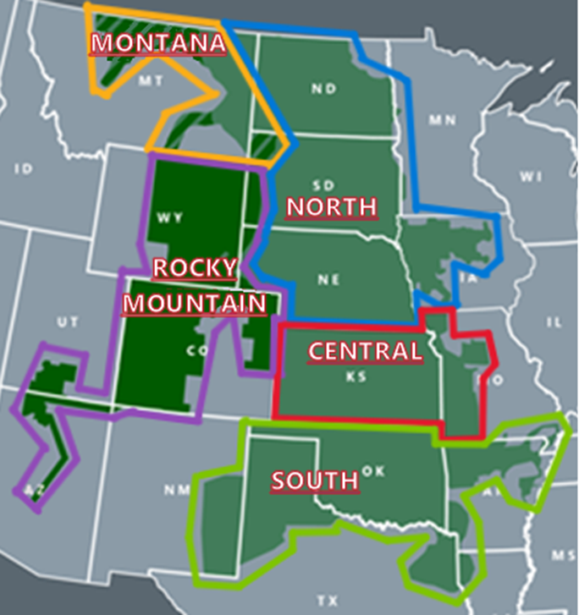

Q: If deliverability has already been evaluated when studying (and granting) NRIS, why is an additional study process required for transmission service?
A: NRIS does not confer transmission service. It merely pre-qualifies generators for the Expedited Designation process. A transmission customer must still request transmission service through the applicable process. The Expedited Designation process does not evaluate new upgrade needs or assign additional upgrade costs; it only evaluates Attachment Z2 Credit Payment Obligations for the request. Z2 Credit Payment Obligations cannot be assessed while studying NRIS service, as the sink of the transmission service path is unknown at this time. This separate Expedited Designation process is used in order to assess Z2 Credit Payment Obligations for these requests consistent with other long-term service requests that are evaluated in the ATSS.

Q: What does the Expedited Designation study process entail?
A: The Expedited Designation process evaluates the request for Base Plan Funding (BPF) eligibility and evaluates impacts on Z2 Creditable Upgrades for the source to sink path of the request. The Z2 Credit Payment Obligations are identified for each upgrade with impacts, and any BPF associated with these Z2 Credit Payment Obligations is identified.

Q: How is the Expedited Designation process different from the ATSS process?
A: The Expedited Designation process is an alternative to the ATSS process. Both processes evaluate long-term transmission service requests before SPP grants the service. A comparison of the two processes is shown below:

ATSS Process | Expedited Designation Process
165 days plus time required to update service agreement | 90 days including service agreement update
Evaluates service upgrade needs and evaluates Z2 Credit Payment Obligations | Evaluates Z2 Credit Payment Obligations only
Aggregates multiple requests into a single study | Each request is studied separately
Any SPP long-term service request can be evaluated | Requirements to enter the process are more stringent

The more stringent requirements to enter the Expedited Designation process include:
- The source must have Network Resource Deliverability through the applicable process,
- The source must be in the same Deliverability Area as some or all of the customer’s network load,
- The capacity of the designation request cannot exceed the threshold described below:
  - For the first year the resource is planned to be designated, SPP will compute the ratio of the Eligible Customer’s system peak responsibility in the Deliverability Area where the resource is located to the Eligible Customer’s system peak responsibility located in all Deliverability Areas in SPP.
  - The capacity of the designation request cannot exceed the generator’s Network Resource Deliverability multiplied by this ratio.

Q: If I enter the Expedited Designation study process, am I obligated to pay any Z2 Credit Payment Obligations that are identified?
A: No. Following study completion and posting, the customer has the option of having SPP accept or refuse the request. The customer must sign and return an Election Form within 3 Business Days in order to have SPP accept the request; at this point, the customer is bound to the Z2 Credit Payment Obligations. If the customer chooses not to return the Election Form, the request will be refused and the customer will only be required to pay study costs, not Z2 Credit Payment Obligations.

Q: Is my request aggregated with other customer requests in an Expedited Designation study? Can I combine multiple service requests into one Expedited Designation study?
A: No, each request is evaluated in an individual study in accordance with Tariff Section 30.2.

Q: What steps do I need to take once my study is completed?
A: Once the study is complete and the report is posted, SPP will email the customer with a notification of the posting. At this point, the customer will need to review the report and decide whether or not they would like to move forward with the transmission service (and the Z2 Credit Payment Obligations). If the customer does not wish to move forward with the transmission service, no further action is required. If the customer wishes to move forward with the transmission service, they will need to sign and return the Expedited Designation Election Form within 3 Business Days. The Election Form will be attached to the study report. After receipt of the Election Form, SPP will accept the OASIS request, and the customer will need to confirm the OASIS request. SPP will also draft NITS Agreement updates and work with the customer on execution and filing of the updated NITS Agreement.

Q: Are the results of my study posted publicly, or shared privately?
A: The study report will be posted publicly on the Transmission Service Studies posting pages. SPP will send notification of the posting only to the customer. The study report will include information such as the customer name, OASIS request start/stop dates, OASIS request MW, Point of Receipt, Point of Delivery, and Z2 Credit Payment Obligations associated with the request. The study report will not include the source or sink of the request.

Q: Where can I find more information about the Expedited Designation process?
A: Tariff Sections 30.2 and 30.2.2 are the main parts of the Tariff addressing the Expedited Designation process. Additional information can also be found in Tariff Sections 29.2, 32, 32.4, Attachment P, and Attachment Z1 Section I.
The Expedited Designation Study Process document can be found on the Transmission Service studies posting page.

