Aggregate Transmission service Study Process
Transmission Services
December 7th, 2023
12th Revision

Revision History
Date or version number | Author | Change Description | Comments
11/11/2015 | Caitlin Shank | Initial version
10/12/2016 | John O’Dell | 1st revision | Updated contact information
04/12/2017 | John O’Dell | 2nd revision | Updated Attestation information
07/25/2018 | Charlton Hill | 3rd revision | Updated group name in document, contact list, email address, & Overview information
03/05/2019 | Bryce Bowie | 4th revision | Update to include new TSR Source field process
09/17/2019 | Josh Ross | 5th revision | Updated contact information
11/26/2019 | Bryce Bowie | 6th revision | Update Section 5.3
05/29/2020 | Josh Ross | 7th revision | Updated contact information
10/5/2020 | Josh Ross | 8th revision | Updated Att Z2 references, report format
11/11/2021 | Josh Ross | 9th revision | Updated account information in Section 10.4
04/04/2023 | Josh Ross | 10th revision | Added more information about BPF calculation practices in Section 6.2, updated contact information
09/13/2023 | Bryce Bowie | 11th revision | Updated Section 4.3. Added more information about source/sink registration and the coordination with Model Coordination for appropriate Settlement Locations
12/7/2023 | Josh Ross | 12th revision | Updated language related to Delivery Point Transfers per RR 548

Contents
Revision History i
1. Introduction 4
2. Quick-Start Guide 4
3. Overview of the Study Process 5
3.1 Flowchart for the Aggregate Transmission Service Study Timeline 6
4. Submitting a Request 7
4.1 Registration as an Eligible Customer 7
4.2 Completed Application Requirements 7
4.3 SPP OASIS request 7
4.4 Aggregate Facilities Study Agreement 8
4.5 Study Deposit 8
4.6 NITS Application 9
4.7 Attestation Statement 9
5. Aggregate Facilities Study Timeline 11
5.1 Open Season 11
5.2 Flowchart for the Aggregate Transmission Service Study Process 11
5.3 Aggregate Facilities Study-1 and Parameter Adjustment 12
5.4 Posting Results for the First Iteration 12
5.4.1 Parameter Adjustments 12
5.4.2 Waiver Requests for Costs over the Safe Harbor Cost Limit 12
5.5 Continuation of Study 12
5.6 Completion of the Aggregate Facilities Study 13
5.7 Steps to a Service Agreement 13
6. Waiver Guidelines 14
6.1 Waiver Types 14
6.2 Eligibility Waiver Requests 14
6.3 Excess Cost Waiver Request 15
6.3.1 Excess Cost Parameter Adjustment and Waiver Request 16
6.3.2 Excess Cost Waiver Request Submission 16
6.4 Waiver Submission and Processing 17
7. Third Party Impacts 18
8. Make-Whole Payment 19
9. Aggregate Facilities Study Guidelines and Information 19
9.1 Evaluation Process 19
9.2 Posted Aggregate Facilities Study Results 20
9.2.1 Aggregate Facilities Study Report 20
9.2.2 Transmission Service Request and Facilities Impacts 20
9.2.3 Redispatch That Is Unavailable For Upgrade 20
9.2.4 An “Accelerated” Upgrade 20
9.2.5 The Upgrade “Solution” In Table 4 20
9.3 Pending Transmission Service 20
9.3.1 When Service Can Begin 20
9.3.2 Deferred Start Date 20
9.3.3 Upgrades 21
9.3.4 Service for Delayed Completion of Study or Until Long Term Service is Available 21
9.3.5 Ending Interim Short Term Service Once Long Term Service Is Available 21
9.3.6 PTP: Study Start Date Doesn’t Line With Power Supply Contract(s) Start Date 21
9.4 Determining Study Costs and Pricing 21
9.4.1 Base Plan Funding of Upgrades 21
9.4.2 Determining Revenue Requirements of Upgrades 21
9.4.3 Transmission Owner(s) Cost Recovery Time 22
9.4.4 Upgrade Revenue Requirements 22
9.5 Upgrade Revenue Crediting 22
9.5.1 Credit Pay Back for Assigned Upgrades 22
10. Study Resources and ContactS 24
10.1 Questions 24
10.2 Study Postings and Announcements 24
10.3 Source and Sink Registration Issues on SPP OASIS 24
10.4 Study Deposit 25
11. Waiver Process Flowcharts 25
11.1 Eligibility Waiver Process Flowchart 25
11.2 Costs Exceeds Safe Harbor Waiver Process Flowchart 26

Introduction
The SPP Aggregate Transmission Service Study (ATSS) is the process for evaluating requests for long-term transmission service, including original requests for new or changed Designated Resources, requests for new point-to-point transmission service, long-term redirects of point-to-point service, Delivery Point Transfers, and most other types of long-term requests.
The ATSS process generally does not apply to requests for new or changed delivery points, re-assignments, or transitions from grandfathered service agreements to SPP service agreements. Transmission Customers should contact the SPP Transmission Services department for guidance as to which process applies.
This document explains the ATSS process, timelines, and requirements. Included is a summation of information contained in the Southwest Power Pool Open Access Transmission Tariff (SPP OATT) and SPP Business Practices. Some details may be omitted. In the event of an omission or discrepancy between this document and the SPP OATT or SPP Business Practices, the SPP OATT and the SPP Business Practices prevail.
Capitalized words in this document indicate defined terms in the SPP OATT and have the same meaning as the SPP OATT.

Quick-Start Guide
In order to request long-term service in the ATSS, a Completed Application must be submitted by the last day of the open season and must include all of the following items:
- A valid SPP OASIS request
- A complete and executed Aggregate Facilities Study Agreement (AFSA)
- A study deposit as indicated in the AFSA
- A NITS Application (only for NITS requests and Designated Resource requests) Documents should be submitted by email to TS@spp.org.
SPP must receive the requests by midnight on the last day of the open season. For more details on each of these requirements, see Section 4 of this document.

Overview of the Study Process
Southwest Power Pool Inc. (SPP) will aggregate all Completed Applications for Long-Term Firm Point-to-Point Transmission Service (PTP) and for Long-Term Network Integration Transmission Service (NITS) that are received by the close of a 6-month open season into one Aggregate Facilities Study (study).
Customers may submit and withdraw SPP Open Access Same-Time Information System (SPP OASIS) Transmission Service Requests (requests) for PTP and NITS during an open season without obligation. At the close of an open season, only requests that are part of a Completed Application will be included in the related study.
After the first iteration of the study, SPP will post the preliminary results on SPP’s OASIS and notify all participating customers in the study.
Posting of the results for the first iteration will open a five-business day window that will allow the customers to adjust the Study Completion Conditions (conditions) in their Aggregate Facilities Study Agreement (AFSA) if their conditions were not met in the initial iteration. If no adjusted conditions are received from the customers with conditions that were not met, then the request will be withdrawn from the study.
If the customer’s conditions were met in the first iteration, then the customer will not be eligible to adjust their conditions. If all customers’ conditions are met in the first iteration of the study, then SPP will deem the study complete.
When the modification window closes, SPP will continue to perform study iterations until all remaining customers’ conditions have been met. SPP will coordinate with the affected Transmission Owner(s) (TO(s)) and will work to complete the study within 165 days.
If SPP is unable to complete the study within the 165 calendar day time frame, then SPP will notify all participating customers and provide an estimate of the additional time that will be needed to complete the study and an explanation of the reason(s) that the additional time will be required.
Once the study is completed, SPP will post the study results and the cost estimates for all requests, including the requests that were removed. All remaining requests that fell within the parameters will be accepted and all the requests that fell outside the parameters throughout the iterations will be refused.
SPP will issue Service Agreements to all customers with requests that have been accepted, except the customers with un-resolved third-party impacts. Customers with un-resolved third-party impacts will be required to complete the third-party process.

3.1 Flowchart for the Aggregate Transmission Service Study Timeline
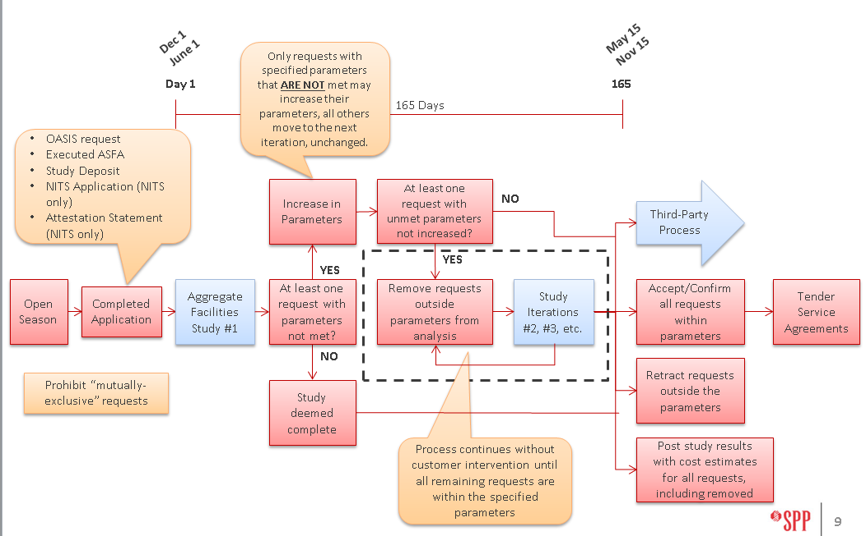

Submitting a Request

4.1 Registration as an Eligible Customer
A prerequisite for participating in the ATSS is to complete the registration process to become an Eligible Customer. SPP Customer Relations staff can assist with the registration process.
Customers should allow sufficient time for the registration process to be completed so that all the study requirements can be met prior to the close of the open season.

4.2 Completed Application Requirements
The requirements and steps that constitute the Completed Application for both PTP and NITS requests are listed below. If a requirement applies only to PTP or NITS service, that will be noted.
For more detail, please refer to Attachment Z1 of the SPP OATT. A Completed Application must include all of the following items.
- A valid SPP OASIS request
- A complete and executed Aggregate Facilities Study Agreement (AFSA)
- A study deposit as indicated in the AFSA
- A NITS Application (only for NITS requests and Designated Resource requests)
Documents should be submitted by email to TS@spp.org.
SPP must receive all of the parts of the Completed Application no later than midnight on the last day of the open season, regardless of whether it falls on a weekend or holiday.

4.3 SPP OASIS request
The Eligible Customer must submit a valid request on the SPP OASIS. If the OASIS request is not submitted by the close of the open season, the request will be considered withdrawn.
It is the Customer’s responsibility to ensure that the OASIS request meets the requirements of SPP’s Business Practices. SPP will review the requests and assist customers as time permits. However, as the close of an open season draws near, SPP’s ability to assist with verification will become limited.
All requests in the same aggregate study, regardless of queue order, receive cost allocation as a group and have the same priority.
All requests must have a term of one year or longer and may start no earlier than 6 months after the close of the open season.
To qualify for renewal at the end of the term the request must span at least 5 full years.
The Source and/or Sink must be valid for the Point of Receipt (POR) and/or Point of Delivery (POD) requested pursuant to SPP Business Practices 2100 and 2150. The only exception is when SPP OATT service is being combined with other SPP OATT transmission service, or service that is grandfathered with respect to the SPP OATT pursuant to SPP Business Practice 2350. For exceptions, the customer must specify a POR and POD for the SPP OATT service that forms a contiguous scheduling path with the other transmission service. Since the POR and POD may not match the Source and Sink (as in the same zone or a system within the Balancing Authority Area) the customer must include comments on the request, indicating that the service is being combined with other service. If this comment is not included, the request status will be refused per sections 2100 and 2150 of the SPP Business Practices.
NOTE: If the Source/Sink is new, then it must be registered in webRegistry/EIR. Once the Source/Sink is registered, please send an email to TS@spp.org indicating the new Source/Sink needs to be added in OASIS. The SPP Transmission Services department will work with the Model Coordination department to ensure this new Source/Sink is mapped to the appropriate Settlement Location. Once this is verified, Transmission Services will request the Tariff Admin department to add the Source/Sink in OASIS so that it will appear in the dropdown option for the ADDNITSDNR request. The customer must also request this new Source/Sink be added to the commercial model through Model Coordination’s normal monthly process. This Source/Sink can be added to the commercial model while the ATSS is being performed. Please do not use a generic ‘Source’ for your request. The ‘Source’ must still be registered in webRegistry.
Wind Resources Requests for new or changed Designated Resources that are wind resources must include a comment indicating that the request is for a wind resource.

4.4 Aggregate Facilities Study Agreement
The Eligible Customer must submit a completed and executed AFSA prior to the close of the open season. If the AFSA is not received by the close of the open season, then the request will be considered withdrawn.
- Download the AFSA from the SPP OASIS Transmission Service Study (TSS) page.
- Specify in the AFSA the conditions under which the customer is willing to accept the requested transmission service.
- Submit the AFSA to SPP by email to TS@spp.org prior to the close of open season.
By executing the AFSA, the customer agrees to take the service requested if the conditions specified in its AFSA are met upon completion of the study.
Upon the close of open season, changes to requests will not be permitted and withdrawal of request will not relieve the customer of its obligation to take the transmission service requested.

4.5 Study Deposit
The Eligible Customer must submit a deposit for each study request. If the deposit is not received by the close of the open season, then the request will be considered withdrawn.
The required deposit amount is calculated by multiplying the maximum amount of transmission capacity requested by $100 per MW. The minimum deposit amount is $5000.

MAXIMUM AMOUNT OF CAPACITY REQUESTED (MW) | REQUIRED DEPOSIT AMOUNT
1 – 50 MW | $5000
Greater than 50 MW | Maximum MW x $100

For profiled requests, the maximum amount of transmission capacity requested is the highest profiled amount over the term of the reservation, regardless of when it occurs.
SPP will invoice the customer at the conclusion of the study for the actual costs less the deposit amount. If the study costs are less than the deposit, SPP will refund the remaining amount with accrued interest.

4.6 NITS Application
For new NITS requests of any kind and for all requests to add or change a Designated Resource, the Eligible Customer must complete and submit a NITS Application prior to the close of the open season. If the NITS Application is not received by the close of open season, then the request will be considered withdrawn.
An example NITS Application is provided on SPP OASIS. For study purposes, unless listed as an exception, all fields must be completed.
If all requests submitted for study represent proposed service under the same Network Operating Agreement, a single application will suffice.

4.7 Attestation Statement
For all requests to add or change a Designated Resource, the Eligible Customer must submit an attestation statement regarding ownership/purchase referenced in section 29.2 of the SPP OATT. This statement will be included during the NITSDNR request submission on NITS on OASIS in the “NITS Resource Designation” section.
The Attested, Attestor Name, Attestation Submitter, and DNR Attestation fields must be completed for the NITSDNR request to be considered valid.
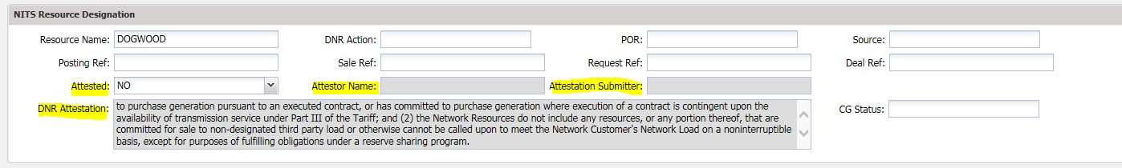
Please use the following statement in the DNR Attestation field:
“All of the Network Resources listed pursuant to Section 29.2(v) satisfy the following conditions: (1) the Network Customer owns the resource, has committed to purchase generation pursuant to an executed contract, or has committed to purchase generation where execution of a contract is contingent upon the availability of transmission service under Part III of the Tariff; and (2) the Network Resources do not include any resources, or any portion thereof, that are committed for sale to non-designated third party load or otherwise cannot be called upon to meet the Network Customer's Network Load on a noninterruptible basis, except for purposes of fulfilling obligations under a reserve sharing program.”

Aggregate Facilities Study Timeline

5.1 Open Season
SPP will receive requests for study during an open season. There are two open seasons annually; each will be 6 months in duration. A customer who enters a request that is subsequently withdrawn before the end of the open season will have no obligation. All requests must have a Completed Application, as described above, to be included in the study.
As currently defined in SPP Business Practice 7500, open seasons will follow this schedule:
STUDY ID | OPEN SEASON
{Year}-AG1 | December 1 – May 31
{Year}-AG2 | June 1 – November 30
Studies will be identified by the Study ID listed in the table, where {Year} is the calendar year in which the Open Season ends.

5.2 Flowchart for the Aggregate Transmission Service Study Process
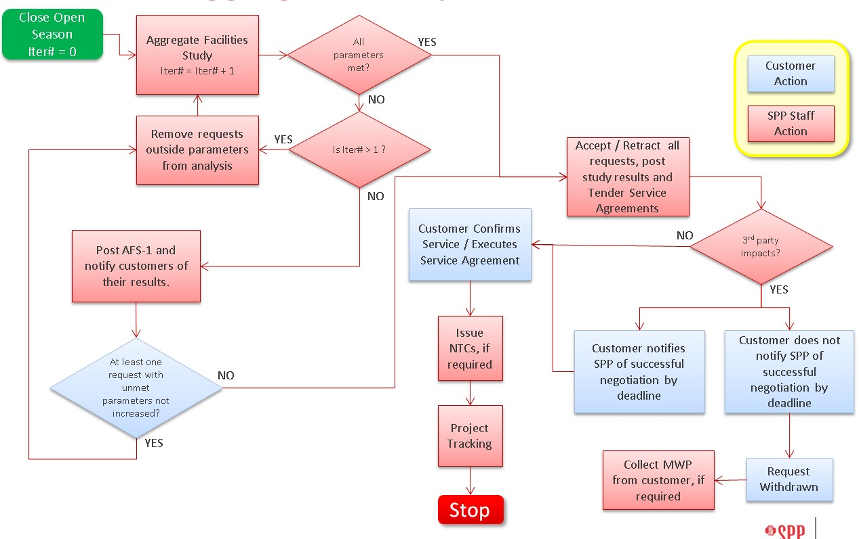

5.3 Aggregate Facilities Study-1 and Parameter Adjustment
SPP will begin the study with Aggregate Facilities Study-1 (AFS-1) at the close of the open season. In AFS-1, SPP will perform a power flow analysis and determine thermal and voltage impacts associated with each request in study.
SPP will coordinate with TOs and third-parties as necessary to validate impacts and determine preliminary upgrades needed to mitigate the impacts. Once complete, SPP will post the results of AFS-1 and will notify each customer of the posting. The posting will include a description of the preliminary upgrades, cost estimates, in-service dates, availability of interim re-dispatch, letters of credit, and directly assigned upgrade costs for each request.

5.4 Posting Results for the First Iteration

5.4.1 Parameter Adjustments
If the results of AFS-1 show that all requests can be provided within all the customers’ parameters, the study will be complete.
If the results show that any request cannot be provided within its parameters, SPP will provide to only those customers with requests outside the parameters a form to increase the parameters, if desired. For example, if the DAUC parameter is set at $500,000 and the allocated DAUC is
$1,000,000, the customer will have the opportunity to increase the DAUC parameter to at least
$1,000,000, and thereby remain in study.
The amended parameters form must be received by SPP within 5 Business Days (a day on which the Federal Reserve System is open for business) of the posting. If no response is received, the original parameters will stand and the request will be removed from the study.
Parameters may only be adjusted if they have been exceeded. Requests that have no exceeded parameters may not be adjusted.

5.4.2 Waiver Requests for Costs over the Safe Harbor Cost Limit
Also, upon the posting of AFS-1, customers may submit requests for waiver of costs in excess of the Safe Harbor Cost Limit. Requests for such a waiver must be received within 15 calendar days of the study posting. See the Waiver section below for more details.

5.5 Continuation of Study
Following the posting of AFS-1 and the passing of the 5 Business Days for parameter adjustment, SPP will continue to evaluate the requests.
As each iteration of the study proceeds, if one or more customer’s conditions are not met, then SPP will remove the request from the study, and will set the status of the request on OASIS to REFUSED, in accordance with SPP Business Practice 7500.
For the requests remaining in the study, SPP will conduct additional iterations, as necessary, to arrive at a set of requests that can be provided within the customer’s stated parameters.

5.6 Completion of the Aggregate Facilities Study
The study will be complete when all customers’ conditions have been met, or no requests remain in study.
SPP will finalize the solution set for the study, the cost estimates for upgrades necessary, and the allocation of the estimated cost to provide each request.
SPP will use due diligence to complete the required study within 165 calendar days for all requests with Completed Applications. SPP will coordinate with the affected TO(s) to complete the study.
If SPP is unable to complete the study within this time, SPP will notify the customer(s) and provide an estimate of the time needed to reach a final determination along with an explanation of the reason(s) that additional time is required to complete the study.
SPP will post a study report on OASIS and notify each customer of the completion and the steps necessary to finalize the Service Agreement.

5.7 Steps to a Service Agreement
Once the study is complete, SPP will notify the customer of the steps necessary to finalize the reservation and service agreement.
    - SPP will advise the customer of any required changes to the OASIS request to align with the final study results. The customer must make any required changes in a timely fashion.
    - SPP will ACCEPT on OASIS all requests that have met the completion conditions.
    - Customers must CONFIRM the request on SPP OASIS within 15 days, in accordance with NAESB requirements.
    - SPP may request a new attestation be provided, if applicable.
    - The customer must provide the required security (Letter of Credit) in accordance with Section III.C, Attachment Z1of of the SPP OATT, within 30 days of confirmation.
    - SPP will issue Service Agreements to all Customers with confirmed reservations, except those with third-party impacts subject to Section III.D, Attachment Z1of the SPP OATT.
    - The customer must execute the Service Agreement or request the filing of an un-executed Service Agreement, within 30 days of receipt.
    - SPP will file an unexecuted Service Agreement with the Commission for any customer failing to execute the Service Agreement or request the Service Agreement be filed unexecuted within 30 calendar days.

Waiver Guidelines

6.1 Waiver Types
There are two types of waiver requests:
    - Eligibility Waiver Request: The request does not meet the eligibility criteria for Base Plan funding of upgrade costs.
    - Excess Cost Waiver Request: The request meets the eligibility criteria, but the costs allocated in the study process exceed the Safe Harbor Cost Limit of $180,000/MW.
Each type has different requirements, timelines, and processes, as outlined below.

6.2 Eligibility Waiver Requests
When completing the NITS Application, the customer is provided with formulas in the spreadsheet intended to assist the customer in making a preliminary estimate of Base Plan funding eligibility for upgrade costs. Any pending changes to existing Designated Resources must be formally submitted prior to the close of the open season to allow those modifications to be taken into account for the official Base Plan funding calculations.
Once the open season is closed, and the study begins, SPP will perform the official calculations for Base Plan funding thresholds, accounting for all existing and requested Designated Resources. All Designated Resources with stop dates greater than 12 months out from the study start date will be assumed to be exercising rollover rights for the purposes of calculating Base Plan funding eligibility, unless the customer elects to include a note in their NITS Agreement stating that they are waiving rollover rights. This NITS Agreement update must be executed before the study start date in order to be incorporated into the Base Plan Funding eligibility calculations.
If a Customer has multiple NITS Agreements, SPP will combine the resources and loads from the associated NITS Agreements or NITS Applications when performing these Base Plan Funding calculations.
Additionally, if a customer submits multiple requests into study and one (but not all) request(s) are withdrawn following a study iteration, SPP will recalculate the Base Plan funding eligibility for that customer by removing the withdrawn request(s) from the calculations.
The eligibility criteria defined in Attachment J, Section III.B.1 are summarized as follows:
    - Term of the request must be at least 5 years.
    - The ratio of the accredited capacity for all Designated Resources to System Peak Responsibility must not exceed 125% in the first year.
    - If the request is for a new or changed wind resource, the ratio of the requested capacity for all the Designated Resources that are wind resources to System Peak Responsibility must not exceed 20% in the first year.
If the customer preliminary estimate determination within the NITS Application indicates that the request is not eligible for Base Plan funding, the customer may submit a request for waiver of the criteria.
The request must be submitted prior to the close of the open season in accordance with the following schedule specified in Business Practice 7500.
Study ID | Close of Open Season | Waiver Submittal Deadline
{Year}-AG1 | May 31 | February 1
{Year}-AG2 | November 30 | August 1
This timing and processing schedule will enable the waiver request to be acted on by the SPP Board prior to the close of the open season, so that the request may be withdrawn if desired.
If a waiver request is not made, or is not made sufficiently in advance to permit processing prior to the close of the open season, and the request is not withdrawn prior to the close of the open season, the customer accepts any and all costs that may be directly assigned at the conclusion of the study process.

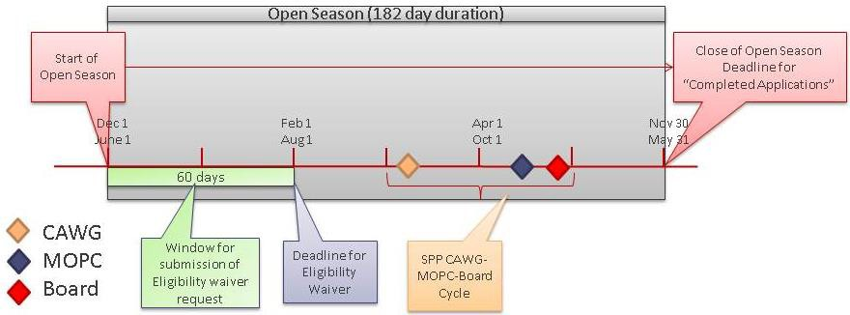

6.3 Excess Cost Waiver Request
In the event that the request is eligible for Base Plan funding, allocated costs that are less than the Safe Harbor Cost Limit will be considered Base Plan upgrades, not directly assigned to the customer. Costs that exceed the Safe Harbor Cost Limit will be directly assigned. These Directly Assigned Upgrade Costs will be identified in the posting of AFS-1.
- If the directly assigned costs in AFS-1 are less than the DAUC parameter, the request will remain in study until conclusion.
- If the directly assigned costs in AFS-1 exceed the DAUC parameter, the customer will be given the option of increasing the DAUC parameter to remain in the study. If the customer chooses not to increase the parameter, the request will be removed from study.
In either case, the customer may request a waiver of costs that exceed the Safe Harbor Cost Limit, whether or not those costs exceed the DAUC parameter.

6.3.1 Excess Cost Parameter Adjustment and Waiver Request
If the costs allocated in AFS-1 do not exceed the DAUC parameter, the customer may still request a waiver of costs that exceed the Safe Harbor Cost Limit.
If the costs allocated in AFS-1 exceed the DAUC parameter, the customer may do one of two things:
- Increase the DAUC parameter and submit a waiver request, or
- Leave the DAUC parameter unchanged and submit both a waiver request and an identical transmission service request in the current open season for the subsequent aggregate study.
In the first case, the waiver request will be processed while the request remains in study. If the waiver request is denied, the customer accepts any and all directly assigned costs that are less than the DAUC parameter at the conclusion of the study.
In the second case, the current request will be removed from study and the waiver request will be processed. If the waiver request is granted, the waiver of costs will be applied to the second transmission service request at the conclusion of the subsequent aggregate study. If the waiver request is denied, the customer may withdraw the transmission service request prior to the close of the open season without further obligation.

6.3.2 Excess Cost Waiver Request Submission
      - The customer may request a waiver within 15 days of the posting of AFS-1.
      - Associated with the waiver request, the customer may submit an identical transmission service request for the subsequent aggregate study.
      - The customer may opt to adjust the DAUC parameter only if it has been exceeded. The adjustment must be made within 5 Business Days of the posting of AFS-1.
      - The waiver of approved costs will be applied to only one of the two TSRs in study.

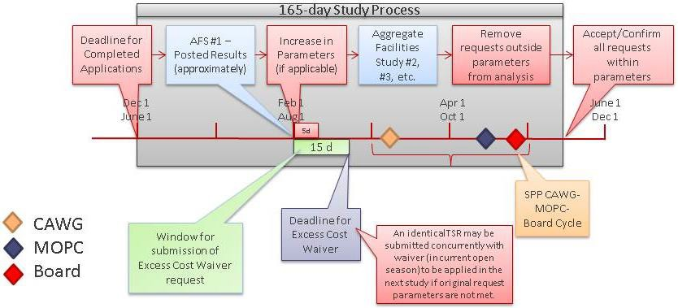

6.4 Waiver Submission and Processing
Waiver requests should be submitted to the Manager, Transmission Services by email at TS@spp.org or the contact listed on SPP’s OASIS Aggregate Study page.
The waiver request must include documentation sufficient for SPP to evaluate the request.
SPP will consult with the Cost Allocation Working Group and will make a recommendation regarding the waiver request to the Markets and Operations Policy Committee. The MOPC and SPP Staff will make a recommendation to the SPP Board and the SPP Board will make its determination on the request.
SPP Staff will apply the result of the SPP Board’s action pursuant to the Tariff and Business Practices.

Third Party Impacts
When the study results indicate a potential impact on facilities other than SPP’s facilities, SPP will follow the procedures of the applicable Joint Operating Agreement regarding long-term transmission service requests and Section 21 of the Tariff.
If the impacts have not been resolved through these processes by the time the study is complete, the disposition of the transmission service request will be deferred until the earlier of (a) the Start Date of the request identified in the study or (b) one year after study completion. The customer may request an extension of this time limit of up to 90 days. If the service would start prior to the end of time extension, the Start Date will be deferred.
Resolution of the impacts may include, but are not limited to, notification from the third-party that the impacts are not valid, notification that the impacts are being resolved through a previously committed upgrade, or notification that the SPP customer has agreed to fund an upgrade.
If the impacts are not resolved within the required time, the request will be deemed terminated and withdrawn. The customer will then be subject to make-whole payments for any shared upgrade costs in accordance with Section III.D.4 of Attachment Z1.
Completion of the Service Agreement will proceed as described above once all third-party impacts have been resolved.

Make-Whole Payment
Make-whole payments may be required when a request that has been terminated after the conclusion of the study (because of third-party impacts) also has shared upgrade costs with another request, and those shared upgrade costs would increase the directly assigned costs for other customers.
SPP will calculate the make-whole payment amount by following these steps:
    - Reallocate total upgrade costs for the remaining confirmed requests in accordance with the provisions of Section IV, Attachment Z1 of the SPP OATT; however, the Directly Assigned Upgrade Cost assigned to each remaining confirmed request will not increase as a result of the reallocation.
    - The make-whole payment assigned to a withdrawn customer’s request will be any reallocated upgrade costs that is in excess of the sum of (i) the Directly Assigned Upgrade Costs and (ii) the amounts included in rates, for any remaining confirmed requests.
    - If there is more than one withdrawn customer’s request, the make-whole payment, if any, will be assigned to the withdrawing customers based on the impact of the withdrawal of each withdrawn customer’s request on those upgrades for which the Directly Assigned Upgrade Costs increased for the confirmed requests, thereby resulting in the make-whole payment.
    - Upgrade costs for facilities only required by the withdrawn customer’s requests will not be included as part of the calculation of the make-whole payment.
    - A customer required to pay a make-whole payment will enter into a Sponsored Upgrade Agreement with SPP in accordance with Attachment J of the SPP OATT and will be eligible for ILTCRs in accordance with Attachment Z2 of the SPP OATT.

Aggregate Facilities Study Guidelines and Information

9.1 Evaluation Process
SPP will identify system constraints and, in conjunction with the applicable TO(s), determine any upgrades required to reliably provide the requests in a manner that minimizes the overall costs for the study group. In identifying the required upgrades, SPP will perform a regional review to determine if alternative solutions would reduce overall cost to customers and incorporate such solutions as appropriate.
The power flow models used for a study will be developed for each season for the period from the earliest start of service to the latest end of service for the applicable requests. The models will include all other applicable existing reservations having equal or greater queue priority including potential renewals of existing service having a reservation priority pursuant to Section 2.2 of the SPP OATT.
SPP will recognize constraints due to contractually limited facilities and allocate available capacity on a first come first served basis on the contractual constraint only.

9.2 Posted Aggregate Facilities Study Results

9.2.1 Aggregate Facilities Study Report
For details regarding the results of the study, please click the link to the Aggregate Study Manual.

9.2.2 Transmission Service Request and Facilities Impacts
The upgrade solution is the optimal aggregate solution after considering all customer requests. To be allocated cost, the request must have at least a 3% Transfer Distribution Factor on the limitation that is relieved by the upgrade and also a positive impact on the upgrade itself.

9.2.3 Redispatch That Is Unavailable For Upgrade
Redispatch is not calculated for voltage or third party limitations. Feasible pairs cannot be determined for flowgates requiring upgrades; meaning the required redispatch of the units would greatly exceed the capabilities of the incremental units due to not having a significant counter flow impact on the flowgate determined by the generator shift factor.

9.2.4 An “Accelerated” Upgrade
When a project is moved up in time from an earlier need date, the customer will be allocated any costs associated with accelerating the upgrade, subject to base plan funding consideration.

9.2.5 The Upgrade “Solution” In Table 4
SPP staff, in conjunction with the applicable TOs, determines the optimal set of solutions to reduce the overall costs for the study group and reliably provide the requests in a timely manner.

9.3 Pending Transmission Service

9.3.1 When Service Can Begin
Service may begin at the conclusion of a study if there are no outstanding prior studies or unresolved third-party issues.

9.3.2 Deferred Start Date
SPP is obligated to provide the request as soon as it is available. A customer cannot elect to start service between the “Deferred Start Date” and the “Deferred Start Date with redispatch,” however, if the service is PTP service, extension of commencement of service may be an option per the SPP OATT section 17.7

9.3.3 Upgrades
If the customer elects to accept interim redispatch in the AFSA, SPP will determine whether interim redispatch is feasible to permit the request to avoid deferral and achieve a start date as close to the requested start date as possible. If so, the service will be provided subject to redispatch. This may restrict or limit the availability of candidate Auction Revenue Rights (ARR) in the SPP Integrated Marketplace. By choosing this option in the AFSA, the customer agrees to this limitation of ARRs.

9.3.4 Service for Delayed Completion of Study or Until Long Term Service is Available
If service is needed and the study completion has been delayed or long term service is not yet available, then interim short term service may be requested as noted in Business Practice 2500 of
SPP’s Business Practices and can be accessed here.

9.3.5 Ending Interim Short Term Service Once Long Term Service Is Available
Short term service can be recalled once the long term service is confirmed to avoid additional payments. Contact the SPP Tariff Administration desk to accommodate request.
Phone 501-614-3247
Email TariffandInterchangeSupport@spp.org

9.3.6 PTP: Study Start Date Doesn’t Line With Power Supply Contract(s) Start Date
For an extension of commencement of service, refer to section 17.7 of the SPP OATT.

9.4 Determining Study Costs and Pricing
All customers entering a study will be responsible for the cost of the study. The cost of the study will be prorated among the customers based on the maximum requested transmission capacity.
If a customer’s cost for the study is less than the deposit, then SPP will refund any remaining deposit with accrued interest, if any.
If a customer’s cost for the study is greater than the deposit, then the customer will be responsible for any cost in excess of its deposit.

9.4.1 Base Plan Funding of Upgrades
Funding for base plan upgrades will be determined per Attachment J of the SPP OATT.

9.4.2 Determining Revenue Requirements of Upgrades
Levelized revenue requirements for service upgrades are based on the revenue stream required to fully compensate the transmission owner over the life of the facility. It includes Weighted Average Cost of Capital as a discount factor, depreciation, taxes, O&M and other applicable fixed charge rates.

9.4.3 Transmission Owner(s) Cost Recovery Time
For customer direct assignment costs, the revenue requirements are recoverable on a monthly basis over the term of the requested service. This value is subject to true up based on updated or final costs.

9.4.4 Upgrade Revenue Requirements
For upgrades associated with PTP service, the Transmission Customer pays the higher of either the Revenue Requirements or the PTP base rate in effect at the time.

9.5 Upgrade Revenue Crediting

9.5.1 Credit Pay Back for Assigned Upgrades
In accordance with Attachment Z2 of the SPP OATT, any Upgrade Sponsor paying Directly Assigned Upgrade Costs for all or a portion of an upgrade is eligible to receive revenue credits or Incremental Long-Term Congestion Rights (ILTCR), provided that there is an agreement authorizing construction of the upgrade with an execution date, or effective date granted by the Commission if filed unexecuted, on or before July 1, 2020. If the date is after July 1, 2020, the Upgrade Sponsor is not eligible to receive revenue credits, but may receive ILTCRs.
As transmission service requests are evaluated in the ATSS process, revenue credits are calculated and reported for all Creditable Upgrades meeting the eligibility described in the previous paragraph.

Study Resources and ContactS

10.1 Questions
Questions regarding the Aggregate Transmission Service Study process can be directed to one of the following SPP Staff members, or by email to TS@spp.org. Questions can also be directed to SPP’s Request Management System.
Name | Email | Phone
Jason Davis, Manager | jdavis@spp.org | (501)614-3374
Josh Ross | jross@spp.org | (501)614-3527
Aaron Jackson | ajackson@spp.org | (501)688-1694
Elias Crespo | ecrespo@spp.org | (501)614-3555
Bryce Bowie | bbowie@spp.org | (501)688-1758

10.2 Study Postings and Announcements
In order to receive pertinent information regarding study postings and general announcements you may join the SPP Aggregate Studies Exploder as outlined below.
To join the exploder:
- Go to SPP.org Exploder Page
- Fill out the form with your information
- Select “SPP Aggregate Studies Exploder”
- Click the “Subscribe” button

10.3 Source and Sink Registration Issues on SPP OASIS
For questions or issues about source/sink registration on SPP OASIS, please contact:
SPP Tariff Administration
501-614-3247 (office phone)
TariffandInterchangeSupport@spp.org (email)

10.4 Study Deposit
Deposits should be remitted to:
Wiring Instructions:
US Bank
800 Nicolett Mall
Minneapolis, MN 55402 Swift# USBK US44IMT
ACH Transfer Instructions: Routing/ABA Number: 082000549 To: Southwest Power Pool, Inc.
Account Number: 151803489070

Waiver Process Flowcharts

11.1 Eligibility Waiver Process Flowchart
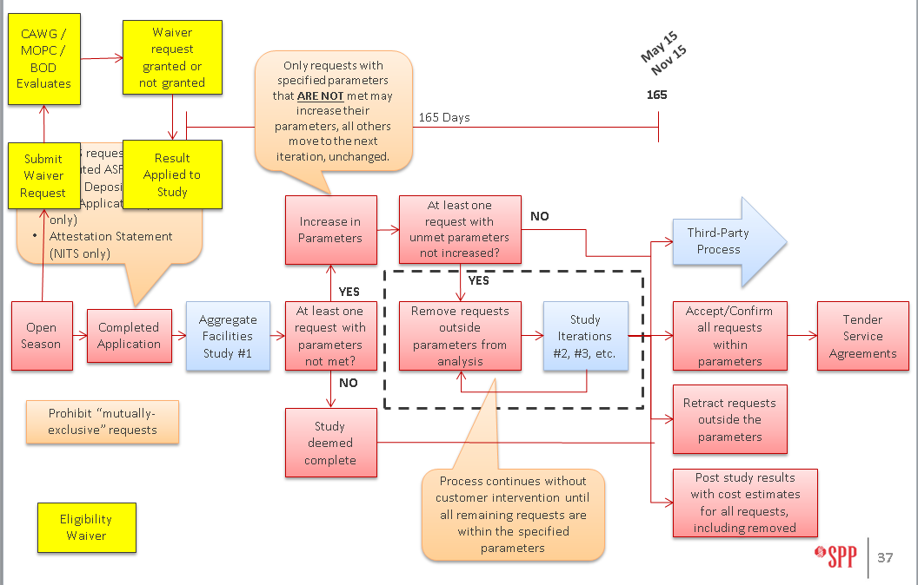

11.2 Costs Exceeds Safe Harbor Waiver Process Flowchart
